**Review of Management Controls for the Scampi 2 Fishery (SCI 2) in 2016**

MPI Discussion Paper No: 2016/11

Prepared for consultation by the Ministry for Primary Industries

ISBN No: 978-1-77665-267-9 (online)

ISSN No: 2253-3907 (online)

June 2016

Disclaimer

The information in this publication is not government policy. While every effort has been made to ensure the information is accurate, the Ministry for Primary Industries does not accept any responsibility or liability for error of fact, omission, interpretation or opinion that may be present, nor for the consequences of any decisions based on this information. Any view or opinion expressed does not necessarily represent the view of the Ministry for Primary Industries.

Requests for further copies should be directed to:

Publications Logistics Officer  
Ministry for Primary Industries  
PO Box 2526  
WELLINGTON 6140

Email: [brand@mpi.govt.nz](mailto:brand@mpi.govt.nz)  
Telephone: 0800 00 83 33  
Facsimile: 04-894 0300

This publication is also available on the Ministry for Primary Industries website at   
<http://www.mpi.govt.nz/news-resources/publications.aspx>

**© Crown Copyright - Ministry for Primary Industries**

Contents Page

1 Submission Information 1

1.1 Official Information Act 1982 1

2 Executive Summary 2

3 Purpose 3

3.1 Issue/Need for action 3

3.2 Management approach 3

4 Background Information 4

4.1 Biological characteristics of scampi 4

4.2 Fishery description 4

4.3 Previous review 5

4.4 New information 6

5 Legal Considerations 7

5.1 Setting management measures 7

5.2 Key considerations 7

5.2.1 Interdependence of stocks 7

5.2.2 Protected species interactions 8

5.2.3 Benthic impacts 8

6 Proposed Options 9

6.1 Option 1 (Status quo) 9

6.2 Option 2 10

6.3 Option 3 10

7 Other Matters 10

7.1 Deemed value rates 10

8 Conclusion 11

# Submission Information

MPI welcomes written submissions on the proposals contained in the Consultation Document. All written submissions must be received by MPI no later than 5pm on Monday 11 July 2016.

Written submissions should be sent directly to:

Deepwater Fisheries Management

Ministry for Primary Industries

P O Box 2526

Wellington 6011

or emailed to [FMsubmissions@mpi.govt.nz](mailto:FMsubmissions@mpi.govt.nz)

## Official Information Act 1982

All submissions are subject to the Official Information Act and can be released (along with personal details of the submitter) under the Act. If you have specific reasons for wanting to have your submission or personal details withheld, please set out your reasons in the submission. MPI will consider those reasons when making any assessment for the release of submissions if requested under the Official Information Act.

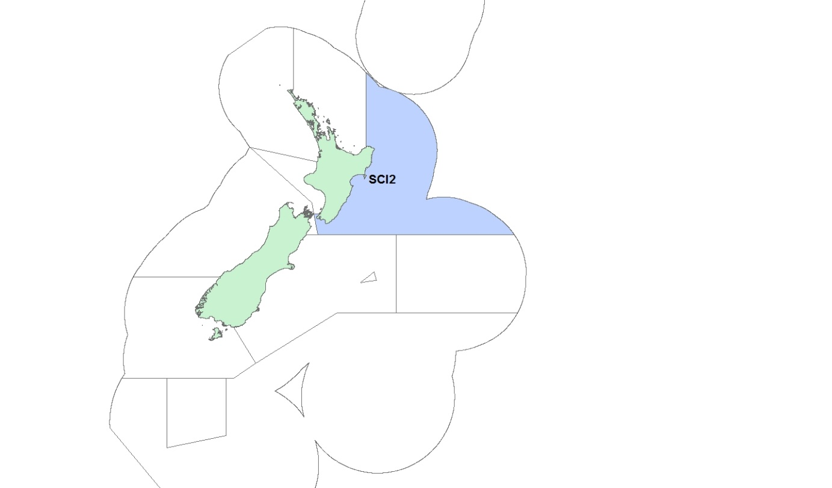

**Figure 1. Quota management area (QMA) for the SCI 2 fishery**

# Executive Summary

The Ministry for Primary Industries (MPI) is seeking tangata whenua and stakeholder input to inform a review of catch limits and allowances for scampi (*Metanephrops challenger)* in quota management area (QMA) 2 (SCI 2; Figure 1).

Results from the 2016 stock assessment indicate SCI 2 biomass is approximately 101% of un-fished biomass (B0), which is well above the default management target of 40% B0. Consequently, MPI proposes an increase of the total allowable catch (TAC) and total allowable commercial catch (TACC) in SCI 2 to utilise the increase in scampi abundance. The specific options proposed for the TAC, TACC and associated allowances are provided in Table 1.

Table 1: Proposed TACs, TACCs and allowances for SCI 2 (all values in tonnes)

|  |  |  |  |  |  |  |
| --- | --- | --- | --- | --- | --- | --- |
| **Option** |  | |  | **Allowances** | | |
| **TAC** | **TACC** | **Increase on current TACC** | **Customary Māori** | **Recreational** | **Other sources of fishing-related mortality** |
| **Option 1** (Status quo) | 140 | 133 | 0 | 0 | 0 | 7 |
| **Option 2** | 161 | 153 | 15% | 0 | 0 | 8 |
| **Option 3** | 182 | 173 | 30% | 0 | 0 | 9 |

There is no known customary Maori or recreational take of scampi and it is proposed to retain zero allowances for these sectors. In addition, MPI proposes to maintain the allocation for other sources of fishing related-mortality at 5% of the TACC. MPI is not proposing any changes to SCI 2 deemed values rates.

MPI considers that the two options proposed in this document to increase the TAC, TACC and associated allowances to utilise the available biomass pose a relatively low sustainability risk.

The SCI 2 fishery is assessed frequently by undertaking fishery-independent surveys every three years, and MPI is confident that appropriate management action will be possible to maintain the stock at or above its default management target.

# Purpose

## Issue/Need for action

In 2016, the SCI 2 stock assessment was finalised and accepted by the Shellfish Working Group (SFWG) and Plenary. The stock assessment indicates that the current (2015) SCI 2 biomass is estimated to be 101% B0, a return to its unfished level as a result of high recent recruitment. The biomass is therefore currently well above the level that will support maximum sustainable yield[1] (MSY) and is very likely (>90% probability) to be at or above the default management target of 40% B0. Projections using various catch levels indicate that the stock will remain at or above the management target with very high likelihood over a five year period.

Given these results, MPI considers that there is an opportunity to increase utilisation based on current and projected biomass estimates.

## Management approach

The scampi fishery is managed under the National Fisheries Plan for Deepwater and Middle-depth Fisheries (National Deepwater Plan), which was approved by the Minister of Fisheries under section 11(a) of the Fisheries Act 1996 (the Act). Within the National Deepwater Plan, scampi is classed as a tier 1 species, and is considered a high value low volume fishery. Tier 1 fisheries are high volume and/or high value fisheries and are traditionally targeted. As part of the National Deepwater Plan, a specific chapter for the scampi fishery is being developed and the necessity for a species-specific harvest strategy will be assessed. In the absence of species specific measures, the fishery is being managed in accordance with the default reference points set out in the Harvest Strategy Standard (Table 2). The Harvest Strategy Standard is a policy statement of best practice in relation to the setting of targets and limits for New Zealand fishstocks managed under the quota management system (QMS).

The status of SCI 2 is assessed every three years using a fully quantitative stock assessment. Each stock assessment is preceded by a dedicated trawl and photographic research survey. The stock assessment methods and results are then evaluated and reviewed by the SFWG. Management is then further informed using projections based on the stock assessment model developed for the SCI 2 fishery.

**Table 2: Scampi default reference points, and the associated management response**

|  |  |
| --- | --- |
| **Reference point** | **Management response** |
| **Management target of 40% B0** | Stock permitted to fluctuate around this management target.  TAC changes will be employed to move stock toward or above target. |
| **Soft limit of 20% B0** | A formal time constrained rebuilding plan will be implemented if this limit is reached. |
| **Hard limit of 10% B0** | The limit below which fisheries will be considered for closure. |
| **Harvest control rule** | Management actions determined by the results of a series of forward projections under a range of catch assumptions, guided by the biological reference points |

# Background Information

## Biological characteristics of scampi

Scampi are burrowing crustaceans that are widely distributed around the continental slope of New Zealand, usually between 200-500 m depth. Studies estimate that scampi are approximately 3-4 years at 30 mm orbital carapace length and may live for 15-20 years. However, the size and growth of scampi within New Zealand has been shown to differ among the regional stocks. Scampi from SCI 2 achieve sexual maturity around 30-36 mm. Larval development is very short, estimated to be less than three days, which suggests low rates of gene mixing between populations. Larval development characteristics and differences in size and growth between populations of scampi support the treatment of SCI 2 as a separate stock.

## Fishery description

The SCI 2 fishery developed through the late 1980s and early 1990s. The number of fishing vessels in SCI 2 has fluctuated, with five to nine vessels fishing in the area over the past five years. The entire New Zealand scampi fleet currently comprises nine vessels of 20-40 m in length. Vessels catch scampi by using a double or triple net configuration.

A competitive catch limit (*i.e.,* no individual allocations) was set for SCI 2 in 1991-92 of 246 tonnes. This was decreased to 200 tonnes when scampi was introduced into the quota management system (QMS) in 2004. The TACC was further decreased in 2011-12 to 100 tonnes due to sustainability concerns based on the outputs of the stock assessment at that time.

During the early 1990s, landings were stable and catch per unit of effort (CPUE) trended upward; however, both declined steadily after 1998-99 until the early 2000s (Figures 2 and 3). CPUE has increased steadily since the early 2000’s, with 2013-14 comparable to records from the mid-1990s. A slight decline has been observed in 2014-15. Landings exceeded the TACC in 2014-15, however this was due to the carry forward of under caught ACE from the previous year as permitted under section 67A of the Act.

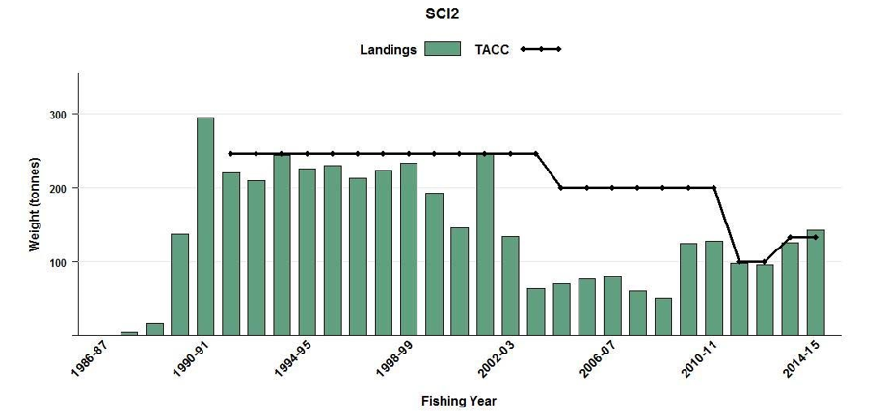

**Figure 2: Annual landings and TACC for SCI 2 between 1986-87 and 2014-15**

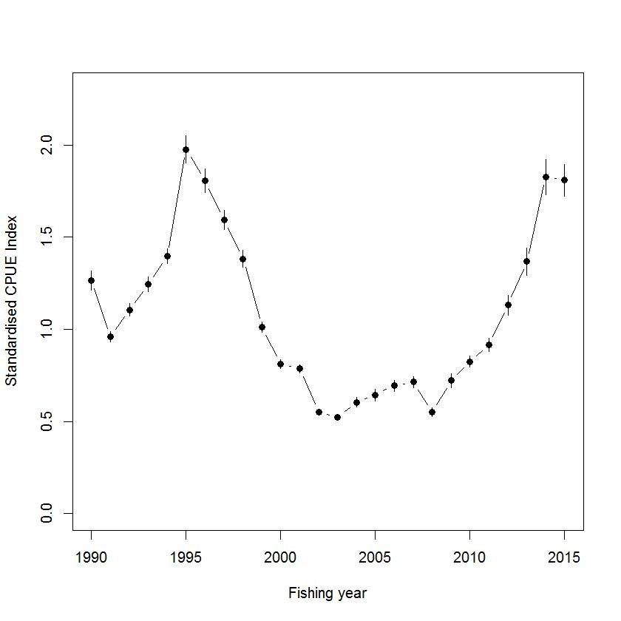

Figure 3: Standardised catch per unit effort (CPUE) for SCI2 from fishing year 1990/91 to the 2014/15 fishing year. Bars represent 95% confidence intervals and the middle dot indicates the median CPUE

## Previous review

An update of the SCI 2 stock assessment was finalised and accepted in 2013. The stock assessment estimated biomass to be 74% B0 and very likely (>90% probability) to be at or above the default target of 40% B0. The TAC was increased to 140 tonnes with a TACC of 133 tonnes.

## New information

An update of the SCI 2 stock assessment was presented to the Shellfish Working Group (SFWG) and Plenary in 2016. The model structure was the same as 2013, however the assessment incorporated new estimates of catchability as well as updated trawl and photo abundance indices from the 2015 research survey. The updated trawl and photo indices suggested a continued increase in abundance since 2006 and follow a similar trend to that observed in the CPUE. Several different models were presented to the SFWG, investigating different assumptions on natural mortality (M), as well as a combined area model incorporating data from SCI 1.

The base case model accepted by both the SFWG and the Plenary was a single area model with M fixed at 0.3. The model estimated that the current (2015) SCI 2 biomass at 101% B0, indicating that current biomass has returned to a level that is very close to the unfished biomass. However, stock trajectory outputs have shown that biomass increased up until 2014, and has declined slightly in 2015. Two additional model runs were presented as sensitivities investigating M fixed at 0.25 and 0.35. Model outputs from the sensitivity runs were consistent with the improvement in stock status outputs of the base case. A recent increase in recruitment is likely to be driving the increase in biomass. Calculations of fishing mortality (F) indicate that overfishing within SCI 2 is exceptionally unlikely to be occurring (Figure 4).

The major sources of uncertainty with this year’s assessment (similar to those of previous assessments) are the lack of information on the growth rate of scampi, the catchability of scampi, natural mortality, and how many scampi occupy one burrow. Research undertaken since the previous assessment in 2013 has addressed some uncertainties concerning emergence patterns and catchability and has been incorporated into the latest assessment.



**Figure 4: The proportion of initial scampi biomass (B0) in SCI 2 in relation to mortality caused by annual fishing intensity. The management target (40% B0), soft limit (20% B0), and hard limit (10% B0) are indicated by dotted vertical lines. The horizontal line indicates the level of fishing mortality that would result in the stock biomass fluctuating at the management target.**

# Legal Considerations

## Setting management measures

Scampi stocks are managed under section 13(2) of the Act. This section requires the Minister to set a TAC that maintains the stock at or above a level that can produce the maximum sustainable yield (MSY), or if the stock is above or below that level, to move towards or above the level that can produce MSY.

Under section 13(3) of the Act, relevant social, cultural and economic considerations must be considered by the Minister in determining an appropriate way and rate to move the stock towards or above a level that can produce the MSY.

The TAC must be apportioned between the relevant sectors and interests set out under the provisions of section 21 of the Act. Section 21 requires the Minister to allow for Maori customary non-commercial interests, recreational fishing interests, and for any other sources of fishing-related mortality, when setting or varying the TACC.

Sections 9(a) and (b) of the Act also require the Minister to take into account that associated or dependent species be maintained at or above a level that ensures their long-term viability, and that the biological diversity of the aquatic environment should be maintained.

Section 12(1)(b) of the Act requires that the Minister provide for the input and participation of tangata whenua and have particular regard to kaitiakitanga before setting or varying a TAC. MPI will provide relevant Fisheries Forums opportunity for engagement on the proposed options.

There is no known customary Maori or recreational take of scampi and it is proposed to retain zero allowances for these sectors. MPI proposes to maintain the allocation for other sources of fishing related-mortality at 5% of the TACC. This nominal allowance accounts for unreported scampi mortality, such as loss due to ripped nets, or discarding of damaged scampi.

## Key considerations

When making a decision concerning the TAC for a stock, the Minister must have regard to the interdependence of stocks, the biological characteristics (discussed above) and any environmental interactions. The key environmental issues and interdependent stocks associated with the SCI 2 fishery are discussed below with reference to the likely impacts of the proposed management options.

### Interdependence of stocks

The scampi fishery has a high level of bycatch, with scampi making up around 19% of the total catch in all observed scampi target tows since 1 October 2005. Based on data recorded by MPI observers, the main bycatch species or species groups were javelinfish (20%), other rattails (7%), and sea perch (10%). The total annual volume of bycatch is variable, but has showed a significant decline since 1990-91, driven mainly by a decline in the bycatch of QMS species. This decline may be partly due to modifications to the top of the trawl to reduce fish bycatch, introduced across the fleet after 2002-03. Bycatch species managed under the QMS comprise about half of total scampi bycatch. If any non-QMS bycatch species are identified through the regular monitoring process as requiring additional management, then the species may be considered for QMS introduction or managed through alternative sustainability measures under section 11 of the Act. Compared to other scampi stocks, SCI 2 has an intermediate level of bycatch. MPI acknowledges that levels of bycatch are likely to increase under the options to increase the TAC that are proposed, however there are processes in place to monitor and manage any risks associated with this increase in bycatch. Planned research for 2016-17 will continue the monitoring and quantification time series of bycatch in scampi fisheries[2].

### Protected species interactions

Management of seabird interactions with New Zealand’s commercial fisheries is driven through the 2013 National Plan of Action to Reduce the Incidental Captures of Seabirds in New Zealand fisheries (NPOA Seabirds). The NPOA Seabirds reflects New Zealand’s obligations under customary international law to take into account the effects of fishing on associated species such as seabirds. MPI has recently undertaken an update to the risk assessment that underpins the NPOA that identifies seabird species considered to be most at risk from New Zealand fisheries.[3] This research has identified that scampi fisheries contribute to 9% of the total risk score for Salvin’s albatross and 15% for flesh-footed shearwater. Both species have been identified as being at very high risk from fishing. However, the proportion of the total risk to both species attributed to scampi fisheries is small as scampi fishing is not the most significant risk to these birds. In addition, the majority of this risk is thought to be generated from the other scampi fisheries, rather than from SCI 2

MPI acknowledges that with increased fishing effort more seabirds may be incidentally captured by the scampi fleet within SCI 2. Non-regulatory management measures are used to reduce the risk of seabird interactions by the scampi fleet. Every vessel targeting scampi has developed a specific vessel management plan (VMP) that sets out the onboard practices vessels must follow to reduce the risk to seabirds, including offal management procedures and deployment of bird scaring devices for vessels under 28 m for which bird scaring devices are not mandatory. MPI monitors each vessel’s performance against its VMP and works with the Deepwater Group Ltd (DWG) to rectify any non-adherence with non-regulatory measures, and also to assist the fleet to improve their offal management practices. These practices will continue in 2016-17.

The capture rate of marine mammals in SCI 2 is very low. It is not thought that the rate of captures is having an adverse effect of the populations of these species.

### Benthic impacts

Bottom trawling for scampi is known to have an impact on benthic habitats. However, the scampi fishery has evolved to use lighter bottom gear with multiple rigs which mitigates some of this impact. Furthermore, fragile benthic invertebrate communities are found primarily on hard substrates that do not occur within the core fishing area of SCI 2, where soft sediment and mud substrate predominates.

The scampi fishery is constrained to a specific depth band and substrate. As a result, an increase in scampi abundance is unlikely to result in a widening of the scampi fishing area, or spreading of scampi fishing into other benthic habitats, but rather an increase in the density of scampi fishing effort within the already exploited area.

MPI will continue to monitor the trawl footprint of scampi and other deepwater fisheries annually.

MPI acknowledges that the options proposed that will increase the TACC will likely result in increased fishing effort and therefore increased contact with the benthos. However, MPI is satisfied that the additional risk this increase in fishing will have on the benthos habitat is low.

# Proposed Options

Given the stock assessment results discussed, MPI is consulting on management options which propose a range of increases in the TAC, TACC, and allowances for SCI 2 (Table 1).

The stock assessment model was used to generate a series of projections that provide estimates of future stock status in relation to B0 and the target and limit reference points. The projections estimate the likely stock status trajectory under different catch scenarios to guide selection of appropriate management settings. Average recruitment from the previous ten years calculated from the stock assessment model is assumed when calculating projections.

To inform the current review of management settings, five year projections have been produced based on a range of constant annual catch scenarios, from current catch levels (averaged over the previous 5 years) of 118 tonnes up to a TACC of 200 tonnes.

All catch scenarios are projected to maintain biomass at or above the management target (40% B0) until 2021 with 98-99% probability. If current catches are maintained at the current TACC, projections indicate that the biomass in 2021 would be 97% B0. Increasing catch to the maximum TACC option proposed of 173 tonnes, would reduce biomass in 2021 to 88% B0 (Table 3). For none of the options proposed do the 95% confidence bounds for each projection scenario drop below the management target of 40% B0. MPI has not proposed to increase the TACC to the level (200 tonne) at which it was set when it was introduced to the QMS as the TACC was then subsequently halved due to sustainability concerns in 2011-12.

Table 3: Probabilities of spawning stock biomass being below or above respective management limits or target; also shown in the bottom row is estimated percentage of B0 the stock is projected to be in 2021

|  |  |  |  |  |  |
| --- | --- | --- | --- | --- | --- |
|  |  | **Current catch** | **Current TACC** | **10% increase** | **30% increase** |
| **2021** |  | **118** | **133** | **146** | **173** |
| **Prob > Hard Limit (10% B0)** |  | 1.00 | 1.00 | 1.00 | 1.00 |
| **Prob > Soft Limit (20% B0)** |  | 1.00 | 1.00 | 1.00 | 1.00 |
| **Prob > Target (40% B0)** |  | 0.99 | 0.99 | 0.99 | 0.99 |
| **B2021/ B0 *100** |  | 93% | 92% | 91% | 88% |

## Option 1 (Status quo)

Option 1 proposes the TAC remains at the current level of 140 tonnes, with a 133 tonne TACC, and a seven tonne allowance for other sources of fishing-related mortality.

Last year 142 tonnes of scampi were landed from SCI 2. Given an estimated export value of $32.88/kg this resulted in approximately $4.67 million in export revenue.[4] Projections indicate that with catch levels at the current TACC, the biomass of the stock will stay above the target until 2021 with 99% probability.

## Option 2

Under this option, the TAC would be increased to 161 tonnes and the TACC would be increased to 153 tonnes (a 15% increase), with an eight tonne allowance for other sources of fishing-related mortality.

Based on an estimate export price of $32.88/kg, an increase of 20 tonnes may result in an additional $657,700 in export revenue. Projections indicate that with a TAC of 161 tonnes, the biomass of the stock will remain above the target until 2021 with 99% probability.

Option 2 and 3 would likely result in increased scampi fishing effort in area 2. Any potential increase in fishing effort is likely to be concentrated in areas that have been previously fished, and any further benthic impacts are likely to be limited.

Increased fishing effort under the proposed options may also increase interactions with protected species. Mitigation measures to reduce seabird captures as part of each vessels’ VMP will continue to be monitored by MPI and any non-adherence will be addressed in collaboration with DWG. Capture rates will continue to be monitored by MPI throughout the year, to ensure increased effort is not having an undue negative impact on these species.

## Option 3

Under this option, the TAC would be increased to 182 tonnes and the TACC would be increased to 173 tonnes (a 30% increase), with a nine tonne allowance for other sources of fishing-related mortality.

Based on an estimate export price of $32.88/kg, an increase of 40 tonnes may result in an additional $1.3 million in export revenue. Projections indicate that with a TAC of 182 tonnes, the biomass of the stock will remain above the target until 2021 with 99% probability.

# Other Matters

## Deemed value rates

Deemed values are an economic tool that provides incentives for commercial fishers not to catch in excess of their individual annual catch entitlement (ACE). Ensuring deemed value rates are appropriately set is a fundamental principle of the QMS. Deemed values are reviewed whenever the TAC for a stock is reviewed.

Current deemed value rates for all scampi stocks including SCI 2 are given in Table 4 below. MPI is not proposing to make any changes to the deemed value rates for scampi at this time.

**Table 4: Current deemed value rates ($/kg) for all SCI stocks including SCI 2.**

|  |  |  |  |  |  |  |  |
| --- | --- | --- | --- | --- | --- | --- | --- |
| **Stock** | **Interim** | **Annual** | | | | | |
| **100-120%** | **120-140%** | **140-160%** | **160-180%** | **180-200%** | **200%+** |
| **SCI - All** | 25.65 | 51.30 | 61.56 | 71.82 | 82.08 | 92.34 | 102.60 |

# Conclusion

MPI is seeking information and views from tangata whenua and stakeholders to support the development of final advice to the Minister on management settings for SCI 2 for the fishing year commencing 1 October 2016.

Results from the 2016 stock assessment indicate SCI 2 biomass is approximately 101% B0, which is well above the default management target of 40% B0. These results demonstrate that the improvement in stock status identified in 2013 has continued, and that there is the opportunity to consider options for increased utilisation in this fishery.

MPI considers that the two options proposed in this document to increase the TAC, TACC and associated allowances to utilise the available biomass as a relatively low sustainability risk.

The SCI 2 fishery is assessed on a relatively short time period of three years between surveys, and MPI is confident that appropriate management action will be possible if the stock declines significantly within the next three years.

1. Deterministic *BMSY* for SCI 2 is estimated to be 27% of the unfished biomass (*B0*),
2. Anderson, O.F. (2012). Fish and invertebrate bycatch and discards in New Zealand scampi fisheries from 1990–91 until 2009–10.
3. Richard, Y.; Abraham, E.R. (2015). Assessment of the risk of commercial fisheries to New Zealand seabirds, 2006–07 to 2012–13.
4. Based on export figures for 2015 calendar year of $32.88 / kg. Scampi does not have its own Harmonised System (HS) code and therefore is captured under shrimps & prawns. No precise product form is assigned therefore a greenweight export price cannot be calculated. The $32.88 / kg figure was calculated for Other Crustacea Frozen (Shrimps and prawns). Precise revenue is difficult to estimate and will be influenced by factors such as commodity prices, exchange rate, catching costs and export state.