Review of Management Controls for the Rubyfish 3 Fishery
(RBY 3) in 2016

MPI Discussion Paper No: 2016/10

Prepared for consultation by the Ministry for Primary Industries

ISBN No: 978-1-77665-266-2 (online)
ISSN No: 2253-3907 (online)

June 2016
Disclaimer
The information in this publication is not government policy. While every effort has been made to ensure the information is accurate, the Ministry for Primary Industries does not accept any responsibility or liability for error of fact, omission, interpretation or opinion that may be present, nor for the consequences of any decisions based on this information. Any view or opinion expressed does not necessarily represent the view of the Ministry for Primary Industries.
Requests for further copies should be directed to:
Publications Logistics Officer
Ministry for Primary Industries
PO Box 2526
WELLINGTON 6140
Email: brand@mpi.govt.nz
Telephone: 0800 00 83 33
Facsimile: 04-894 0300
This publication is also available on the Ministry for Primary Industries website at
http://www.mpi.govt.nz/news-resources/publications.aspx
© Crown Copyright - Ministry for Primary Industries

Contents Page

1 Submission Information 1
1.1 Official Information Act 1982 1
2 Executive Summary 2
3 Purpose 3
3.1 Issue/Need for action 3
3.2 Management approach 3
4 Background Information 3
4.1 Biological characteristics of rubyfish 3
4.2 Fishery description 4
4.3 Previous review 4
4.4 New information 5
5 Legal Considerations 5
5.1 Setting management measures 5
5.2 Further considerations 6
6 Proposed Options 7
6.1 Option 1 (Status quo) 7
6.2 Option 2 8
6.3 Option 3 8
7 Other Matters 8
7.1 Deemed value rates 8
8 Conclusion 9

Submission Information
MPI welcomes written submissions on the proposals contained in the Consultation Document. All written submissions must be received by MPI no later than 5pm on Monday 11 July 2016.

Written submissions should be sent directly to:
Deepwater Fisheries Management
Ministry for Primary Industries
P O Box 2526
Wellington 6011

or emailed to FMsubmissions@mpi.govt.nz

Official Information Act 1982
All submissions are subject to the Official Information Act and can be released (along with personal details of the submitter) under the Act. If you have specific reasons for wanting to have your submission or personal details withheld, please set out your reasons in the submission. MPI will consider those reasons when making any assessment for the release of submissions if requested under the Official Information Act.

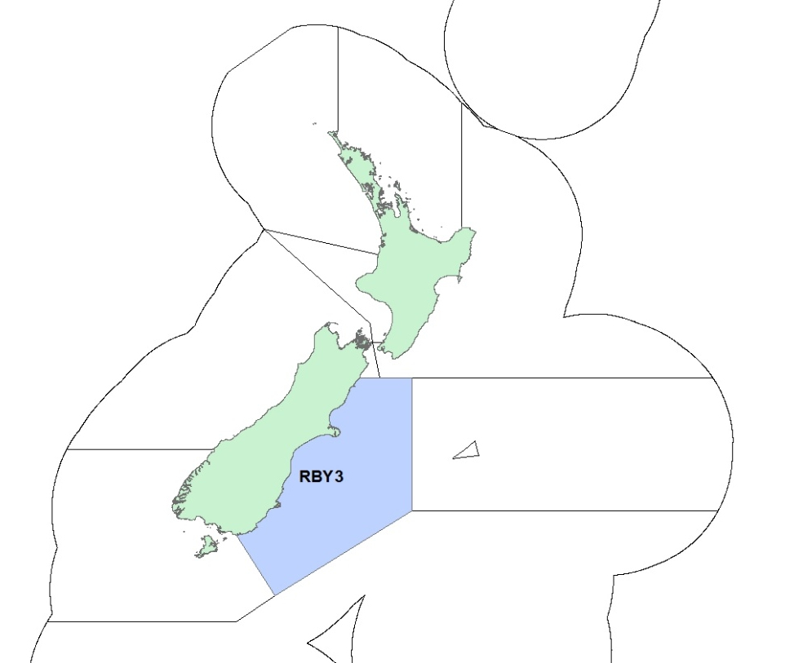

Figure 1. Quota management area (QMA) for RBY 3

Executive Summary
The Ministry for Primary Industries (MPI) is seeking information and views from tangata whenua and stakeholders to inform a review of catch limits and allowances for the rubyfish (Plagiogeneion rubiginosum) stocks in fishery management area 3 (RBY 3; Figure 1).

Rubyfish stocks were introduced into the quota management system (QMS) on 1 October 1998. The total allowable catch (TAC) and a total allowable commercial catch (TACC) for the RBY 3 stock were initially conservatively set at three tonnes. These initial catch limits were determined by adding 10% to the average annual catch reported for the seven fishing years between 1990/91 and 1996/97.

The RBY 3 TACC has remained unchanged at three tonnes since the stock was introduced into the QMS with a nominal TACC. Between 1998/99 and 2013/14 the average annual catch from this stock was 1.1 tonnes. In 2014/15 however, reported catch was 14.3 tonnes and as at April 2016, catch for the 2015/16 fishing year was 29 tonnes. This is likely due to increased fishing effort for related species such as redbait in RBT 3 increasing the amount of rubyfish caught as bycatch.

RBY 3 is a low knowledge stock with little or no information with which to reliably estimate stock status. MPI proposes a small increase the TACs and TACCs for the stock as set out in Table 1 below. MPI considers that because the proposed catch limits will remain at relatively low levels and are unlikely to cause a sustainability risk, setting the TAC at the levels proposed is not inconsistent with the objective of maintaining the stocks at or above the levels that produce maximum sustainable yield (MSY).

Table 1 sets out MPI’s initial proposals for catch limits and allowances for RBY 3.

Table 1. Proposed TACs, TACCs and allowances for RBY 3 (all values in tonnes)
Option |  |  | Allowances
 | TAC | TACC | Customary Māori | Recreational | Other sources of fishing-related mortality
Option 1 (status quo) | 3 | 3 | 0 | 0 | 0
Option 2 | 16 | 15 | 0 | 0 | 1
Option 3 | 32 | 30 | 0 | 0 | 2

In all cases MPI proposes to retain the existing zero allowance for customary Māori and recreational fisheries. For options other than the status quo, MPI proposes a small allowance for other sources of fishing related mortality.

Purpose

Issue/Need for action
The primary rationale for reviewing the TAC for RBY 3 is the large (relative to the conservative nominal TACC) catch reported during the 2014/15 and 2015/16 fishing years. Increased redbait effort in RBT 3 (including RBY 3) since 2012/13 is likely driving this increase, with associated increases in the volume of rubyfish bycatch. RBY 3 catch during 2014/15 was just under five times the TACC while as at April 2016, catch for the 2015/16 year is almost 10 times the TACC. Considering the current nominal TAC for RBY 3, a relatively moderate increase to the TAC is not considered a sustainability risk, and in combination with the proposed changes to rubyfish deemed value rates (see section 7.1) would retain the incentive for fishers to correctly report catches.

Management approach
Rubyfish is managed under the National Fisheries Plan for Deepwater and Middle-Depth Fisheries (National Deepwater Plan), which was approved by the Minister of Fisheries under section 11A of the Fisheries Act 1996. Within the National Deepwater Plan it is classed as a Tier 2 species. Tier 2 fisheries are typically less valuable bycatch fisheries or are only target fisheries at certain times of the year.

For rubyfish, as with most Tier 2 species, there is insufficient information to undertake a stock assessment and determine stock status in relation to default target and reference points.

Rubyfish will be included in future work focused on monitoring and managing low-information stocks.

Background Information

Biological characteristics of rubyfish
Rubyfish is found in New Zealand waters as well as parts of the Atlantic and Indian Oceans and other parts of the South Pacific Ocean. It belongs to the same family as redbait and catch distribution suggests it aggregates around features.

In New Zealand waters the species has, to date, been uncommon south of the Chatham Rise and South Westland. It is much more common around the North Island, with target fisheries in the Bay of Plenty and off the east coast of the North Island taking between 300 and 600 tonnes per year between them.

Rubyfish is thought to be long-lived, growing to a maximum age of around 100 years. Growth appears to be rapid for the first 10 years or so, reaching lengths of 35-40cm. Growth rates then slow, reaching a maximum length of around 57cm.

It is not known whether different regional stocks of rubyfish occur in New Zealand waters. It may, however, be appropriate to consider the RBY 3-5 stocks as a unit.

Fishery description
As already noted, all rubyfish stocks were introduced into the QMS in 1998 with a nominal three tonne TACC for RBY 3. Annual catch for the stock since 1998 is shown in Figure 2 below.

Figure 2. Catch vs TACC for RBY 3 between 1998/99 and 2015/16 (as at April 2016)

Figure 2 shows catches of only a few hundred kg in most years. Prior to 2014/15 catch had exceeded the TACC on only two occasions (1999/00 and 2006/07).

In all instances where more than a few hundred kg has been reported, most catch can be traced to a very small number of fishing events. Of the 48 tonnes of estimated catch of RBY 3 reported on trawl catch effort and processing returns (TCEPRs) between 1998/99 and 2015/16, 95% was taken on just six tows around the Mernoo Bank. The reported target species for the six tows were redbait (four tows), jack mackerel (one tow) and hoki (one tow).

Previous review
The TACC for RBY 3 has not been reviewed since the stock was introduced into the QMS in 1998.

New information
Other than reported catch, there is no new information for the RBY 3 stock. The status of all rubyfish stocks relative to B_{MSY} is unknown.

The highest annual catches of both stocks have been reported in the period after QMS introduction in 1998. It is unclear, however, whether this represents an increase in abundance, better reporting, or a change in fishing activity in the areas where rubyfish is likely to be encountered. However increased targeting of redbait in recent years (including increased redbait catch in RBY 3 from 2012/13) is likely to have increased the amount of rubyfish caught as bycatch.

Legal Considerations

Setting management measures
The lack of biomass information means the TACs for the RBY 3 stock would be set under section 13(2A) of the Act. This section is relevant for stocks for which the maximum sustainable yield (MSY) is not able to be reliably estimated using the best available information.

Section 13(2A) requires the Minister for Primary Industries (the Minister) to set a TAC that is not inconsistent with the objective of maintaining the stock at or above, or moving the stock towards or above, a level that can produce the MSY. The options within this paper provide the Minister with a choice on how he fulfils his obligations under this section. Initial TACs were set at nominal levels and subsequent adjustments have occurred on a similar basis. Given the nature of the fisheries and the small increases proposed, MPI considers that options to increase the TACs for RBY 3 are not inconsistent with the objective outlined above.

Under section 13(3) of the Act, relevant social, cultural and economic considerations must be considered by the Minister in determining an appropriate way and rate to move the stock towards or above a level that can produce the MSY.

The TAC must be apportioned between the relevant sectors and interests set out under the provisions of section 21 of the Act. Section 21 requires the Minister to allow for Māori customary non-commercial interests, recreational fishing interests, and for any other sources of fishing-related mortality, when setting or varying the TACC.

Section 12 (1)(b) of the Act requires that the Minister provide for the input and participation of tangata whenua and have particular regard to kaitiakitanga before setting or varying a TAC. MPI will provide relevant Fisheries Forums opportunity for engagement on the proposed options.

Recreational and customary Māori allowances are currently set at zero and MPI proposes to retain these allowances for all options. Given the distance offshore and depth where this species is found, MPI considers that zero allowances are appropriate. However, MPI would welcome information from stakeholders on whether non-zero allowances should be set.

The allowance for other sources of fishing related mortality is currently set at zero for RBY 3. MPI proposes that this allowance be set at either one or two tonnes for all TAC options other than the status quo option.

Further considerations
When making a decision concerning the TAC for a stock, the Minister must, under section 12(2A), have regard to interdependence of stocks, the biological characteristics (discussed above) and any environmental conditions affecting the stock.

Sections 9(a) and (b) of the Act also require the Minister to take into account that associated or dependent species be maintained at or above a level that ensures their long-term viability, and that the biological diversity of the aquatic environment should be maintained.

The key environmental interactions associated with the two rubyfish stocks are discussed below with reference to the likely impacts of the proposed management options. As almost all rubyfish in the two areas is taken as bycatch, the proposed TAC options for both stocks are unlikely to have much, if any, influence on fishing activity. For this reason environmental interactions are not expected to change if the TACs for these stocks were to increase.

Seabirds
Management of seabird interactions with New Zealand’s commercial fisheries is driven through the 2013 National Plan of Action to Reduce the Incidental Captures of Seabirds in New Zealand fisheries (NPOA Seabirds). The NPOA Seabirds reflects New Zealand’s obligations under customary international law to take into account the effects of fishing on associated species such as seabirds.

The NPOA Seabirds has established a risk-based approach to managing fishing interactions with seabirds, targeting management actions at the species most at risk as a priority but also aiming to minimise captures of all species to the extent practicable.

The level of risk from commercial fishing to individual seabird species has been identified through a comprehensive hierarchical risk assessment that underpins the NPOA Seabirds. Seabird interactions from the target fisheries that take RBY 3 and RBY 4 as bycatch generally occur at low rates, although interactions are known to occur. These fisheries were assessed to contribute very low levels of risk to a small number of seabird species.

With the range of regulatory and non-regulatory measures in place, the management proposals should have no additional effects on seabirds as effort is unlikely to change.

Fish bycatch
Rubyfish is not targeted in RBY 3. For this reason fish bycatch is not expected to change regardless of the TAC options.

Marine mammals
The capture rate of marine mammals (fur seals and dolphins) in the RBY 3 QMA is low and it is not thought that the rate of captures is having an adverse effect of the populations of these species.

The management proposals should have no additional effects on marine mammals as fishing effort is not expected to change.

Benthic impacts
Since QMS introduction in 1998, over 70% of rubyfish taken in RBY 3 has been taken using mid-water trawl gear that is fished on or close to the bottom.

The increases in TAC proposed for the RBY 3 stock are unlikely to change the nature of the fisheries of which rubyfish in RBY 3 is a bycatch. MPI will continue to monitor the trawl footprint of all deepwater fisheries, including those that take rubyfish as bycatch, on an annual basis.

Proposed Options
MPI is consulting on the options set out in Table 3. Aside from the status quo, all options involve comparatively modest increases to catch limits for the stock. MPI also proposes retaining the existing zero allowance for customary Māori and recreational fisheries. A small (one or two tonne) allowance for other sources of fishing-related mortality is proposed to account for unreported mortality of fish that, for example, are lost from the net during hauling and are not reported by vessel operators.

In the absence of abundance information, catch of rubyfish reported in recent years is used as the basis for the proposed options, which MPI considers are not inconsistent with the objective prescribed for these stocks.

MPI has little information on the value of rubyfish. It is not identified as a separate species in export statistics and the 2016/17 port price survey indicated considerable variation between stocks; from a low of $0.25/kg for RBY 4 to a high of $2.29/kg for RBY 1 and a weighted average for the species of $1.88/kg.

MPI understands that rubyfish is not a particularly valuable species and is worth considerably less than alfonsino, the target fishery where rubyfish is most commonly taken as bycatch. For this reason, together with the relatively small quantities that are caught in RBY 3, even the highest TAC options proposed probably only equate to a few tens of thousands of dollars in additional revenue for the fishing industry. MPI welcomes any additional information from stakeholders on the value of this species.

Table 3. Proposed TACs, TACCs and allowances for RBY 3 (all values in tonnes)
Option |  |  | Allowances
 | TAC | TACC | Customary Māori | Recreational | Other sources of fishing-related mortality
Option 1 (status quo) | 3 | 3 | 0 | 0 | 0
Option 2 | 16 | 15 | 0 | 0 | 1
Option 3 | 32 | 30 | 0 | 0 | 2

Option 1 (Status quo)
Under this option the TAC/TACC for RBY 3 would remain at three tonnes. The fact that catches of more than three tonnes of rubyfish in a single tow have been achieved several times indicates it may not be appropriate to retain the TAC at this level.

This option does not provide incentives for fishers to correctly report catches. Total deemed values of over $2,000 were incurred during the 2014/15 fishing year and this is likely to be at least doubled during 2015/16.

Option 2
This option involves setting the RBY 3 TAC at 16 tonnes with a TACC of 15 tonnes. This option is based on catch reported during the 2014/15 fishing year and is well above the average catch for the 17 completed fishing years since 1998/99.

A TAC at this level remains relatively low in comparison to the TACs for the main rubyfish stocks of RBY1 (TAC of 318 tonnes) and RBY2 (435 tonnes) and is considered unlikely to lead to sustainability concerns for this stock.

Option 3
This option involves setting the RBY 3 TAC at 32 tonnes with TACC of 30 tonnes. This option is based on catch reported during the first half of the 2015/16 fishing year. This option would provide fishers with an increased ability to cover catch with ACE in the event of encountering a large aggregation of rubyfish while targeting a different species.

Again, a TAC at this level is considered unlikely to lead to sustainability concerns for this stock.

Other Matters

Deemed value rates
Deemed values are an economic tool that are designed to create incentives for commercial fishers not to catch in excess of their individual annual catch entitlement holdings. Ensuring deemed value rates are appropriately set is a fundamental principle of the Quota Management System. Reviewing deemed value rates is undertaken whenever a TAC for a stock is also reviewed.

The existing and proposed deemed value rates for all rubyfish stocks are set out in Table 4 below.

Table 4. Existing and proposed deemed values rates ($/kg) for all rubyfish stocks
 | Stock | Interim | Annual 100-120% | Annual 120-140% | Annual 140-160% | Annual 160-180% | Annual 180-200% | Annual 200%+
Existing | RBY1 | 0.14 | 0.28 | 0.336 | 0.392 | 0.448 | 0.504 | 0.56
 | RBY2 | 0.11 | 0.21 | Differential deemed value rates do not apply
 | RBY 3 | 0.10 | 0.19
 | RBY 4 | 0.21 | 0.42 | 0.504 | 0.588 | 0.672 | 0.756 | 0.840
 | RBY5 | 0.11 | 0.21 | Differential deemed value rates do not apply
 | RBY6 | 0.11 | 0.21
 | RBY7 | 0.378 | 0.42
 | RBY8 | 0.21 | 0.42
 | RBY9 | 0.11 | 0.21
Proposed | All stocks | 0.25 | 0.28 | 0.336 | 0.392 | 0.448 | 0.504 | 0.56

Table 4 indicates there is considerable inconsistency between the deemed value rates for rubyfish stocks. The 2016/17 port prices for rubyfish stocks are summarised in section 6 above while the lack of export value information is also noted in that section.

For RBY 3 there is limited ACE trading data and in most years there is insufficient data to generate an average annual trade price. Average annual ACE trade price for RBY 4 has been between $0.20 and $0.30/kg for the last 10 years while the figure is between $0.10 and $0.12/kg for RBY 7.

MPI proposes to standardise deemed rates for all rubyfish stocks using the existing RBY 1 deemed value rates as the basis. In accordance with the Deemed Value Guidelines, the interim deemed value rate would be set at 90% of the 100-120% annual rate (i.e., increased from $0.14/kg to $0.25/kg). All stocks would also have the same 100-120% annual deemed value rate and differential deemed value rate would also apply to all stocks at the same rates that currently apply to RBY 1. MPI considers this approach is consistent with the Deemed Value Guidelines.

Conclusion
MPI is seeking information and views from tangata whenua and stakeholders to support the development of final advice to the Minister on management settings for RBY 3 for the fishing year commencing 1 October 2016.

All rubyfish stocks were introduced into the QMS in 1998 with catch limits based on average catch reported in the years prior to QMS introduction. The TAC for RBY 3 has not been reviewed since being introduced.

Rubyfish is a species that is more commonly found around the North Island. The west coast of the South Island (the RBY 3 QMA) represents the southern edge of its distribution on the east coast and it is uncommon south of these areas.

Rubyfish in this area is taken as bycatch to other target species. In RBY 3 it is most often taken while targeting redbait while in RBY 4 it is most often taken while targeting alfonsino. Infrequent, large catches of up to 30 tonnes per tow are responsible for most rubyfish catch in these areas.

This consultation document proposes that the TACs for the RBY 3 stock be increased in response to catch exceeding the TACC in recent years. With the exception of the status quo the proposed increases are based on the recent levels of catch, continuing the approach used as the basis for the earlier increases to the RBY 4, RBY 7 and RBY 8 TACs.

Considering that the current TACC for RBY 3 is a nominal legacy value and that recent increases in effort for related species are likely behind current catch increases, the relatively minor TAC and TACC increases proposed are not only unlikely to cause a sustainability risk, but also retain incentives for correct catch reporting.

For all options MPI proposes to retain the existing nil allowance for recreational and customary Māori catch and to set small allowances for other sources of fishing related mortality.

For more information on this please refer to the corresponding consultation paper addressing deemed value rate changes for the 2016/17 fishing year.

