Operating manual for AAA Plants Ltd
- Table of Contents
1 INTRODUCTION 3
1.1 Revision history 3
1.2 Distribution list 3
1.3 Contact details 4
1.3.1 Facility operator: 4
1.3.2 Facility manager 4
1.3.3 Local MPI Office 4
1.3.4 Staff 4
2 SCOPE 5
3 MANAGEMENT 6
3.1 Management structure 6
3.1.1 Facility operator: 6
3.1.2 Facility manager 6
3.2 Document control and amendments 7
3.3 Management review 7
3.4 Records 8
3.5 Staff training 8
3.6 Internal audits 8
3.7 External MPI inspections 9
3.8 Non-compliances 9
3.8.1 Critical or major non-compliance 9
3.8.2 Minor non-compliance 9
3.9 Facility checks 9
4 THE QUARANTINE FACILITY 10
4.1 Facility description 10
4.1.1 Site plan 10
4.1.2 Facility plan (not to scale) 11
4.2 Security and access to the facility 11
4.3 Standard biosecurity work practices 12
4.3.1 Facility hygiene 12
4.4 Transfer of plant material from the on-arrival inspection facility 13
4.4.1 Transfer of material to the PEQ facility 13
4.4.2 Transfer of material to a treatment facility 13
4.5 Receiving plant material at the facility 14
4.6 Processing plant material 15
4.6.1 Processing consignments of Dracaena deremensis 15
4.7 Disposal of waste 15
4.8 Plant inspections by the manager 15
4.9 Plant inspections by the MPI inspector 16
4.10 Reporting and identifying pests and disease 16
4.10.1 Collection of samples for disease diagnosis 16
4.11 Treatment of plants in PEQ 17
4.11.1 Approved treatment technician 17
4.11.2 On-arrival treatment of plant material 17
4.12 Mixing of consignments 17
4.13 Multiplication of material in PEQ 17
4.14 Contingency plans 18
4.14.1 Detection of live insects when a consignment is being unpacked 18
4.14.2 Theft of material from a facility 18
4.14.3 Major damage to facility (e.g. by storm, earthquake, fire or other event) 18
4.14.4 Minor damage to facility 19
Appendix 1 Names and responsibilities of authorised staff employed at AAA Plants 20
Appendix 2 Register of training undertaken by employees at AAA Plants Ltd 21
Appendix 3 Internal audit checklist 24
Appendix 4 Checklist for monthly checks of the facility by the facility manager 26
Appendix 5 Checklist for weekly inspection of insect traps 27
Appendix 6 Example of sign at entrance to PEQ facility 28
Appendix 7 Register of visitors 29
Appendix 8 Footbath refilling records 30
Appendix 9 Example letter of authorisation for collection of plant material from the on-arrival inspection facility 31
Appendix 10 Weekly plant inspection record 32
Appendix 11 Treatment register 33

INTRODUCTION

Revision history

Version Number | Description of Changes | Reviewed by | Approved by | Issue Date
1.0 | Original version of operating manual | Alex Diamond | Lucy Campbell | 18/05/2015

Distribution list

Name | Position | Address | Copy Number
Abu Iqram | Containment Verifier - Plants | Ministry for Primary Industries  19 Richard Pearse Drive  PO Box 53066  Auckland | 1
Lucy Campbell | Director | 123 Green Valley Road  Hamilton  3204 | 2
Alex Diamond | Facility manager | 123 Green Valley Road  Hamilton  3204 | 3

Contact details
This section lists contact details for the facility operator, the facility manager, and the Ministry for Primary Industries (MPI) containment verifier for the facility.

Facility operator:
Lucy Campbell
Director
123 Green Valley Road
Hamilton
3204
Phone: (01) 234 5678
Mobile: 035 236 569
Email: lucy.campbell@AAAplants.co.nz

Facility manager
Alex Diamond
123 Green Valley Road
Hamilton
3204
Phone: (01) 234 5679
Mobile: 035 236 571
Email: alex.diamond@AAAplants.co.nz

Local MPI Office
Abu Iqram
Containment Verifier-Plants
Ministry for Primary Industries
19 Richard Pearse Drive
PO Box 53066
Auckland Airport
Auckland
Phone: 64-9-909 8522
Fax: 64-9-909 8558
Mobile: 029-909 8522
Email: Abu.Iqram@mpi.govt.nz

Staff
Names and responsibilities of all permanent staff members with access to the facility are given in Appendix 1.

SCOPE
This operating manual has been developed to describe the procedures used to ensure that AAA Plants Ltd meet the requirements of the MPI Facility Standard for Post Entry Quarantine for Plants and also relevant requirements in the import health standard (IHS) 155.02.06: Importation of Nursery Stock.
The facility is used to securely contain imported nursery stock (rooted and non-rooted cuttings) that is eligible for import into a level 2 post entry quarantine (PEQ) facility according to the requirements of IHS 155.02.06: Importation of Nursery Stock.
Types of plant imported into the facility include (but are not limited to) whole plants of Abelia x grandiflora, Hibiscus syriacus, Hydrangea paniculata and Penstemon barbatus and non-dormant cuttings of Dracaena deremensis. Other plant species with an import specification of L2 (basic) may also be imported.
Material can be released from the facility once all import requirements have been met, and permission has been given by the MPI inspector to grant a biosecurity clearance in the form of a Biosecurity Authority/Clearance Certificate (BACC).

MANAGEMENT

Management structure

Facility operator:
Lucy Campbell
Director
123 Green Valley Road
Hamilton
3204
Phone: (01) 234 5678
Mobile: 035 236 569
Email: lucy.campbell@AAAplants.co.nz
The operator has responsibility for:
- Overall accountability of the facility, its maintenance and management;
- Ensuring that adequate technical and financial resources are in place to operate the facility;
- Ensuring that the facility and procedures continue to comply with registration requirements;
- Undertaking internal audits;
- Liaising with MPI to arrange external audits;
- Annual review, update and version control of this operating manual;
- Annual management review;
- Training of staff;
- Notifying the MPI inspector of the following:
  - When any non-compliances occur
  - When consignments arrive at the facility
  - When active growth starts
  - When any pests or diseases are detected
  - When any changes are proposed to any physical/structural or operational aspects of the facility;
- Applying for biosecurity clearance for all consignments;
- Ensuring that up to date records of all relevant information and documents relating to imported plant material are maintained;
- Ensuring that all material is retained within the facility until a biosecurity clearance is given.
Note: When the operator is absent the above responsibilities will be delegated to the facility manager, who has been approved by the MPI inspector as being suitably qualified to act as the operator in the Approved operator’s absence, and has undertaken the PEQ operator training programme.

Facility manager
Alex Diamond
123 Green Valley Road
Hamilton
3204
Phone: (01) 234 5679
Mobile: 035 236 571
Email: alex.diamond@AAAplants.co.nz
The facility manager has the authority to direct staff and visitors to the facility on any matters relating to compliance as required under any MPI standards and is responsible for:
- Collecting plant material on arrival in New Zealand;
- Overseeing unpacking and processing of plant material on arrival;
- Ensuring that up to date records of all relevant information and documents relating to imported plant material are maintained;
- Conducting monthly checks of the facility to ensure compliance with the physical requirements of the MPI Facility Standard for Post Entry Quarantine for Plants;
- Conducting plant inspections on a weekly basis.

Document control and amendments
The operator is responsible for:
- Approving all amendments and documentation prior to distribution;
- Updating the revision history (section 1.1 of this document) after any amendments are made to this operating manual. A brief description of any changes will be identified in the revision table to ensure that these changes are easily identifiable and the page numbers of changes will be indicated;
- Ensuring that the MPI inspector approves any amendments before they are implemented;
- Ensuring that all versions of the operating manual in circulation (as identified in section 1.2 of this document) are the most current version and that any old copies held within the facility are destroyed or retained separately as below;
- Ensuring that the distribution list (section 1.2) for copies of this manual is kept up to date;
- Collecting and retaining for seven years at least one copy of obsolete versions of the operating manual.

Management review
The operator and facility manager will hold an annual meeting to review the management system (including the operating manual) annually. The review will include the following items:
- Review of internal and external audits;
- Review of monthly facility checks;
- Review of any non-compliances and corrective actions taken over the previous year;
- Staff training that has been undertaken over the previous year;
- Any suggestions from staff regarding improvements to the system;
- Availability of resources to allow ongoing compliance with the facility standard;
- Any other business.
Records of the review, in the form of minutes taken at the annual meeting, will be retained for seven years.

Records
Records will be maintained for the facility and for each consignment held in quarantine and retained for a minimum of seven years. As a minimum, these records will consist of:
- Facility and file records including:
  - Facility and operator approvals;
  - Records of facility checks, audits and management reviews;
  - Records of any non-compliances issued and any corrective or preventative actions that are taken;
  - Names of staff employed at the facility and records of staff training and relevant qualifications.
- Consignment file records including:
  - Copies of import permits, phytosanitary certificates and any BACCs or movement authorisations relevant to the consignment;
  - Records of the identity (genus, species, cultivar), quantity and date of imports;
  - Dates of destruction or release of any material;
  - Records of any treatments applied to plants in quarantine;
  - Records of inspections and any pest detections and identifications;
  - Quarantine unit in which the plants are housed.

Staff training
The operator is responsible for training all people who work in the facility. Training includes:
- Ensuring all staff who have access to the facility are familiar with basic biosecurity and quarantine requirements (as identified in section 4.3 of this manual);
- Ensuring all staff who have access to the facility are trained and competent in all procedures (as listed in part 4 of this manual) which they are required to use whilst working in the facility;
- Ensuring that all staff who have access to the facility are supervised by a trained member of staff until they have demonstrated that they are competent in procedures which they are required to use;
- Maintaining training records that are signed off by the facility operator as shown in Appendix 2.
- Refresher training will be provided as required and will be mandatory if any non-compliances are identified that arise from staff actions, or if changes are made to processes or procedures used in the facility.

Internal audits
The operator will undertake an audit of the facility every six months to:
- Verify that all processes continue to comply with the requirements of this operating manual
- Identify any areas where systems can be improved and make recommendations where potential improvements are noted
A checklist showing what will be assessed during the internal audit is given in Appendix 1.

External MPI inspections
The MPI Inspector will complete an inspection (audit) of the facility every six months. If the MPI inspector has not contacted the operator to advise that an external inspection will be carried out before the external audit is due, the operator will contact the Inspector by email and remind them that the facility is due for inspection.

Non-compliances
Non-compliances may be identified by staff at any time, during audits or facility checks, or as a result of unexpected events such as storms. In the event of non-compliances being identified, actions described in the following sections will be taken.

Critical or major non-compliance
Anyone who notices a critical or major non-compliance must notify the operator immediately. The operator will then take the following actions, as required in the standard:
- Notify the MPI inspector immediately (in the case of a critical non-compliance) or within one business day (in the case of a major non-compliance). If the MPI inspector cannot be contacted, the operator will call the Pest and Disease hotline on 0800 80 99 66;
- Take immediate corrective action to restore compliance;
- Discontinue any activity related to the critical non-compliance that presents a biosecurity risk;
- Notify the MPI inspector when corrective actions have been completed;
- Record the incident, and any corrective action(s) taken.
Examples of critical or major non-compliances which may occur include the following:
- Loss, theft or accidental removal of plant material from the quarantine unit;
- Unauthorised access to the facility;
- Significant damage to the facility structure;
- Modifying a facility without approval from the MPI inspector;
- Failure to record imports in the activity register;
- Failure to action corrective action requests;
- Failure to complete internal audits or monthly checks of the facility.

Minor non-compliance
In the event of minor non-compliances being identified (e.g. spider webs or moss identified during an audit), the following actions will be taken:
- Take corrective action to rectify the non-compliance within five working days;
- Record the incident and any corrective actions taken;
- Notify the inspector on the next audit or visit.

Facility checks
The facility manager will check the facility on a monthly basis to ensure that all the physical requirements of the standard continue to be met. A checklist showing what will be checked is given in Appendix 2.

THE QUARANTINE FACILITY

Facility description
The facility is located at 123 Green Valley Road and consists of a standalone 6 mm twin wall polycarbonate greenhouse with all vents covered by stainless steel mesh (0.6 mm minimum aperture) built on a concrete pad. The facility consists of two 4 x 6 metre units arranged alongside each other with an anteroom (2 m long) at the front of the facility allowing entrance to each unit. A hand basin and an automatic insecticide dispenser are located in the anteroom. All plants within the facility will be grown on raised galvanised metal benches (720 mm high).

Runoff from the greenhouse is via screened drains with silt traps that exit to a sewer system. The facility is surrounded on all sides by a 1.5 m wide concrete buffer strip.

Site plan

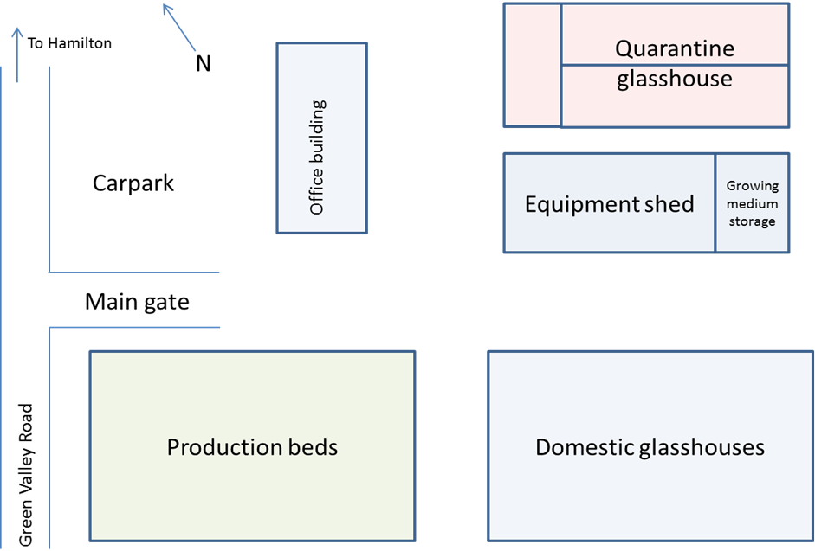

Facility plan (not to scale)

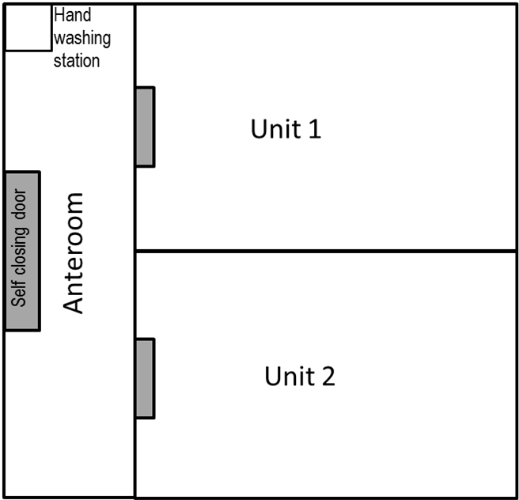

Security and access to the facility
Entrance to the nursery site is via a gate that is kept locked outside business hours.
The door to the anteroom of the PEQ facility is kept locked at all times except when staff are working within the facility. A key to the facility is held by the operator and the facility manager. An additional key is held at reception, with instructions that it may only be used to access the facility when permission has been given by the operator. A prominent sign at the entrance to the facility states that access to the facility is restricted (see Appendix 4).
Access to the facility is restricted to the following groups of people:
- Trained, authorised staff. A list of permitted staff who are allowed to enter the facility is provided in Appendix 1 of this operating manual.
- Visitors (including contractors) who are approved by the operator and manager and whose names have been recorded in the visitors log book. All visitors must be accompanied whilst in the facility. The visitors log book is held at reception in the office building. An example of information recorded in the log book is given in Appendix 5.
- The MPI inspector

Standard biosecurity work practices
All users and visitors to the facility will comply with the following measures at all times whilst in the facility:
- All visitors will be signed in at reception before entering the greenhouse;
- All people entering the facility will ensure that they use the footbath located at the entrance to the anteroom;
- Doors to the facility will not be propped open and will be kept shut when not in use. When entering the greenhouse, one door (either the door to the anteroom or to the greenhouse unit) will be kept closed at all times;
- All doors will be kept open for the minimum time necessary;
- Protective clothing (overalls) will be worn at all times in the facility. Disposable coveralls are provided for visitors; these will be retained in the anteroom or disposed of in the quarantine bin before leaving the facility;
- Disposable gloves will be used when handling plant material. Gloves will be disposed of in the quarantine bin in the anteroom before leaving the facility;
- All people who enter the facility will wash their hands in the anteroom immediately after entering and before leaving the facility;
- No plant material will be removed from the facility without authorisation by the operator;
- No tools will be removed from the facility unless they have been decontaminated using the procedure outlined in section 4.3.1;
- Any damage to the facility must immediately be reported to the operator or manager;
- Any signs of pests or diseases must immediately be reported to the operator or manager.

Facility hygiene

Footbath
A footbath is located inside the entrance to the anteroom. The footbath consists of a shallow tray lined with absorbent felt. This is saturated with Virkon® solution (30 g/litre). The facility manager will ensure that the Virkon® solution is replenished a minimum of once per week, or as necessary.
The footbath will be emptied and thoroughly cleaned at least once every 3 months, or as necessary.
All replenishments and refills of the foot bath will be recorded on the table shown in Appendix 6.

Floors
Any spillages of material (e.g. potting mix) on the floor will be removed immediately. Any dropped leaves or other material will be regularly removed from the greenhouse chamber and placed in the quarantine bin in the anteroom. All waste will be placed in the quarantine bin in the anteroom.
Algal growth on floors will be removed as necessary by scrubbing with a hard broom. Floors and walls of each unit will be thoroughly cleaned between consignments. Any weeds, lichen or mosses found within the facility will be removed and disposed of in the quarantine bin.

Insect traps
Two yellow sticky insect traps will be placed in each quarantine unit, approximately 25 cm above the canopy. One sticky trap will also be placed in the anteroom. The date of placement will be written on each trap. Sticky traps will be replaced after each consignment, and retained until inspected by the MPI inspector.
Traps will be checked at least once per week (when plant inspections are being done). All checks of insect traps will be recorded on the table shown in Appendix 8.

Cleaning of tools
All tools will remain in the quarantine facility at all times. Tools will be cleaned in freshly prepared 1% sodium hypochlorite (bleach) by dipping in the solution then wiping with a disposable paper towel to remove any visible plant material, and the repeating the dip-wipe process. Sodium hypochlorite will always be prepared the same day that it is to be used.
As a minimum, cutting implements will always be decontaminated between plants from different lots or consignments.

Cleaning of facility between consignments
The facility will be thoroughly cleaned between each consignment by brushing down walls as necessary and cleaning all floors and benches using a pressure washer.

Transfer of plant material from the on-arrival inspection facility

Transfer of material to the PEQ facility
Once a BACC has been issued authorising transfer of the material to AAA Plants Ltd, the facility manager will collect the plant material from Auckland Air Cargo and transfer it directly to the PEQ facility. Contact details for Auckland Air Cargo are as follows:
Ogilvie Crescent
PO Box 53-066
Auckland International Airport
Phone: 09 909 8631
Facsimile: 09 256 0452
When collecting the goods, the facility manager will present a letter of authorisation from the operator, authorising the manager to collect the plant material. An example authorisation letter is given in Appendix 7. When collecting the goods, the manager will ensure that they are securely packaged to prevent any loss of material during transport.
On arrival at the PEQ facility all plants will immediately be transferred (unopened) to the greenhouse chamber in which they will be grown.

Transfer of material to a treatment facility
When material requires an on-arrival treatment, a BACC will be issued authorising transfer of the material to an MPI-registered treatment facility. In this case, the facility manager will collect the plant material from Auckland Air Cargo as described in section 4.4.1 and transfer it directly to the treatment facility. Once the treatment has been applied another BACC will be issued authorising transfer to the PEQ facility.
When collecting the goods from the treatment facility, the facility manager will present a letter of authorisation from the operator, authorising the manager to collect the plant material. An example authorisation letter is given in Appendix 7.
On arrival at the PEQ facility all plants will immediately be transferred (unopened) to the greenhouse chamber in which they will be grown.

Receiving plant material at the facility
Once the material has been transferred to the greenhouse chamber in which it will be held, the operator will complete the following actions before opening the consignment:
- Check the BACC to ensure that all details are correct. This will include verifying that the on-arrival inspection of the consignment has been completed at the border and that on arrival treatments have been applied (if required);
- Notify the MPI inspector by email that the consignment has arrived and that all details on the BACC are correct. This will be done within one business day of the arrival of the consignment;
- Inform the MPI inspector within one business day if any of the following apply to a consignment:
  - Details on the BACC are incorrect
  - A consignment arrives that is not accompanied by a BACC
  - A consignment arrives that has not been inspected at the border.
If any of the above apply to a consignment that arrives at the facility the operator will ensure that the consignment remains unopened and is stored securely within the quarantine unit in which the material is to be grown until further direction has been received from the MPI inspector describing actions that should be taken for the non-compliant consignment.
Once the above actions have been completed, the operator will also undertake the following actions and will inform the facility manager that they can process the plant material as described in the following section:
- Assign a unique number to the consignment (or to each lot in the consignment if there is more than one lot).
- Update the facility’s activity register to include the following information:
  - Date received
  - Consignment number (CXXXX number at top of BACC)
  - Copy of BACC and/or movement authorisation forms
  - Copy of import permit
  - Copy of phytosanitary certificate
  - Genus, species and cultivar names of plants in the consignment
  - The unique number assigned to the consignment (or to lots within the consignment)
  - Number of plants of each species in the consignment
  - Greenhouse unit in which the material is located

Processing plant material
Once the operator has informed the facility manager that plant material can be processed, the following actions will be completed:
- Ensure that a dual action aerosol insecticide spray (Raid Multipurpose Odourless Fly and Insect Killer) is present within the greenhouse chamber in case any live insects are present.
- Disinfect all working areas and benches on which the plants will be grown using Virkon S® (10 g/litre) prior to unpacking and potting.
- Unpack the material and inspect for pests and disease. If any live insects are detected, the actions taken in section 4.14 (Contingency plans) of this document will be followed. If any other pests or diseases are observed, the MPI inspector will be notified within 24 hours and material will be re-sealed until further direction is provided by the inspector.
- Treat material with fungicide by dipping in a combination of Aliette and Topsin as described in section 4.11 of this manual.
- Pot up into new pots or trays as soon as possible after plants have been unpacked and treated. Plants will be grown in a mixture of peat and perlite that is prepared on-site and is stored undercover in the equipment shed prior to use.
- All plants will be grown on raised benches.
- Plants from each lot will be kept on separate benches, with each bench clearly labelled with the unique number assigned to that lot.
- Once material is potted up, all waste associated with the consignment will be disposed of as described in section 4.7 of this operating manual
- The activity log will be updated to record the date the material was planted.

Processing consignments of Dracaena deremensis
All consignments of Dracaena deremensis will be spray treated with a mixture of Perfekthion S (1.1 g active ingredient per litre) and Hortcare Spinosad (2 g active ingredient per litre) as required in the Dracaena schedule of the IHS 155.02.06: Importation of Nursery Stock. This treatment will occur 14 days after the on-arrival treatment was applied at an MPI accredited treatment facility and will be applied by the approved treatment technician as described in section 4.11 of this operating manual.

Disposal of waste
All users of the facility will ensure that all plant waste and any material associated with imported plants (e.g. packaging waste, used gloves etc.) is placed in the sealed bin in the anteroom.
Once each consignment has been given a biosecurity clearance, all waste material from each consignment will be transferred (in the sealed bin) to the on-site boiler room for destruction by incineration. If the bin is filled before a consignment is cleared, the operator will contact the MPI inspector to request that the material be disposed of by incineration.
Disposal of waste (date and method) will be recorded in the activity register for each consignment.

Plant inspections by the manager
Plants will be inspected once a week by the manager for any signs of pests or disease. All plants will be inspected for obvious symptoms of pests or disease and a subset of plants will be more closely inspected by an examination of the tops and bottoms of leaves, including closer examination of any buds and the junctions where stems and leaves meet using a hand lens.
Records will be kept of all inspections, with all observations recorded on the weekly inspection record table (Appendix 8). When multiple consignments are being held within the facility, a separate table will be completed for each consignment.
If any symptoms of pests or diseases are detected, the MPI inspector will be informed using procedures identified in section 4.10 of this manual.

Plant inspections by the MPI inspector
The operator will inform the MPI inspector when plants enter an active state of growth, so that the MPI inspector is able to commence growing season inspections as specified in the nursery stock import health standard.

Reporting and identifying pests and disease
If any signs of pests or disease are identified in plants in quarantine, the operator will inform the MPI inspector within 24 hours of symptoms being identified. If the MPI inspector cannot be contacted, the MPI hotline will be informed on 0800 80 99 66.

Collection of samples for disease diagnosis
The following steps will be taken if the MPI inspector advises that samples need to be collected in order to diagnose the presence of a pest or disease:
- The manager will be responsible for collecting all samples;
- The MPI inspector will be emailed with details about the samples to be submitted and will be asked to provide a laboratory submission form;
- Powder free disposable gloves will be worn when collecting samples. A new pair of gloves will be worn for collecting each sample when samples are taken from more than one plant;
- Samples will be collected from symptomatic plants using a gloved hand, with samples taken from the margin of diseased and healthy tissue where possible;
- Each sample will be transferred to a zip-lock plastic bag that is clearly labelled with the permit, consignment and lot (where applicable) numbers as well as a unique number that is assigned to the individual plant from which the sample was taken;
- When tools (e.g. secateurs) are used to collect samples, these will be sterilised between each plant using the procedure described in 4.3.1;
- Each plant from which a sample is taken will be clearly labelled so that the sample sent to the laboratory can be easily traced back to the plant from which it was taken;
- Samples in zip-lock bags will be placed within a polystyrene box that contains an ice pack. The ice pack will be wrapped in bubble wrap to prevent samples from freezing;
- Once all samples have been collected, the polystyrene box will be sealed with adhesive tape and placed within a secure outer container (constructed of rigid plastic);
- A completed laboratory submission form will be placed within the secondary container, and the container will then be clearly labelled and securely sealed using adhesive tape;
- Samples will then be sent by track and trace courier to the following address (unless advised otherwise by the MPI inspector):
MPI Investigation & Diagnostic Centres & Response
231 Morrin Road
St Johns
Auckland
- The laboratory will be contacted by phone (09 909 3015) to advise them of shipping details for the samples.

Treatment of plants in PEQ

Approved treatment technician
The MPI-approved treatment technician for the facility is Charlie Wells, who holds a Growsafe Introductory certificate (valid until 21/03/2017). All treatments applied to plants in the facility will be applied by the treatment technician.
Treatments will only be applied as described in the following sections, or when approval has been given by the MPI inspector for specific cases and a BACC has been issued stating the treatment to be undertaken.
All treatments will be applied within the time period specified by the MPI inspector (where applicable) and using a method of application approved by the MPI inspector or as specified in the relevant IHS or import permit.
When treatments are required, all plants within the affected quarantine unit will be treated.
All treatments will be recorded in the treatment register as shown in Appendix 9.

On-arrival treatment of plant material

On-arrival treatment of herbaceous plants
When plants have been unpacked they may be treated by dipping in a combination of Aliette® and Topsin® for a period of 2-5 minutes immediately prior to planting.

Post-arrival treatment of Dracaena deremensis
All consignments of Dracaena deremensis will be sprayed with a combination of Carbaryl (1.2 g per litre) and Spinosad (2.0 g per litre) 10-14 days after the on-arrival treatment was applied to the plants. Sprays will be applied only by the approved treatment technician.

Mixing of consignments
From time to time the operator may wish to grow different consignments in the same greenhouse chamber. In this case, the operator will inform the MPI inspector of their intention to do so at the same time as they apply for the import permit.

Multiplication of material in PEQ
From time to time the operator may wish to multiply plants that are being held within the PEQ facility. The following steps will be taken when multiplying plants:
- Approval will be obtained from the MPI inspector before any multiplication is undertaken.
- All plants will be retained within the facility and will be clearly traceable to the consignment and lot (where applicable) from which they are derived.
- At all times, plants will be handled according to procedures describe in this operating manual.
- Plants will undergo inspections whilst in the facility as described in sections 4.8 and 4.9 of this operating manual.

Contingency plans
Contingency plans have been developed for the situations described below as follows:

Detection of live insects when a consignment is being unpacked
In the event that mobile insects are detected when a consignment is being unpacked, the following actions will be taken:
- Immediately re-seal the consignment so that no insects can escape;
- Spray the greenhouse chamber with a dual action insecticide (Raid Multipurpose Odourless Fly and Insect Killer);
- Leave the greenhouse chamber and place a sign on the door stating that live insects have been detected in the consignment and no-one must enter the unit;
- Ensure that MPI is notified of the presence of the mobile insects immediately. Initially this will be done by contacting the MPI inspector (Abu Iqram, 09 909 8522). If the MPI inspector is not available the MPI hotline will be contacted on 0800 80 99 66;
- Ensure that the facility operator is informed of the presence of mobile insets within the consignment;
- Ensure that the consignment remains isolated within the greenhouse unit further direction is received from MPI.

Theft of material from a facility
In the event of imported plant material being stolen from the facility, the following actions will be taken:
- The operator will notify the MPI inspector (Abu Iqram, 09 909 8522) as soon as possible, and within 24 hours of the theft being observed. If the inspector cannot be contacted, the MPI hotline will be contacted on 0800 80 99 66;
- The police will be informed of the theft, and of the fact that the material was imported into New Zealand and was being held in a quarantine facility according to MPI requirements;
- The operator will work with MPI and the police to recover the stolen material;
- The operator will keep MPI informed as to the status of the stolen material.

Major damage to facility (e.g. by storm, earthquake, fire or other event)
In the event of major damage to the facility (defined as a breakage in the cladding that cannot easily be repaired), the following actions will be taken:
- Temporary repairs will be attempted (for example by using polythene sheeting and weather-proof adhesive tape). Spare polythene sheeting is located onsite in the equipment shed;
- If the operator considers that the temporary repairs are sufficient to contain the quarantine material and any organisms that may be associated with it, the MPI inspector will be contacted (within 24 hours). If the inspector cannot be contacted, the MPI hotline will be contacted on 0800 80 99 66;
- If MPI agree that the temporary measures will be adequate to temporarily contain the plant material, the operator will arrange for permanent repairs to be made to the facility. These repairs will be carried out as soon as possible and within two business days and the MPI inspector will be informed upon completion of repairs. When repairs are being completed, the operator will ensure that any plants within the quarantine unit are sealed off within that unit so that any pests or diseases that may be associated with the imported material will be unable to escape from the facility;
- If the facility is damaged beyond easy repair, the MPI inspector will be contacted and arrangements will be made to securely transfer the plant material to another facility or to a secure building until repairs are completed.

Minor damage to facility
In the event of minor damage to the facility (for example hairline cracks in the facility or small holes in insect proof mesh), the following actions will be taken:
- The staff member who detects the damage will take immediate action to temporarily seal the damaged area;
- After temporary repairs have been made the staff member will inform the operator of the damage;
- A suitably qualified person will be contacted to make permanent repairs within three business days of the damage being identified;
- A record will be made in the activity register of the damage, and steps that were taken to repair the damage.

Names and responsibilities of authorised staff employed at AAA Plants

Name | Position | Responsibilities | Qualifications and/or experience
Lucy Campbell | Owner/Facility operator | See section 3.1.1 of this operating manual | Diploma in Agribusiness Management  National certificate in Nursery Production (Level 4 Advanced)
Alex Diamond | Facility manager | See section 3.1.2 of this operating manual | National certificate in Nursery Production (Level 4)
Charlie Wells | Nursery worker/ treatment technician | On arrival treatments of consignments as required, application of any additional treatments authorised by the MPI inspector  Assisting with potting up of new consignments  Cleaning of facility between consignments  Disposal of biosecurity waste | Growsafe introductory certificate  National Certificate in Horticulture - Introductory (Level 2)

Register of training undertaken by employees at AAA Plants Ltd

Basic greenhouse quarantine training and biosecurity awareness
Employee name
Trainer name
Date of training | Measure | Employee signature | Trainer signature*
 | Only authorised people are allowed to enter the facility. All visitors must be recorded in the log book (held at reception) and approved by the operator or facility manager.
 | Doors must not be propped open. At least one door must remain closed at all times. Doors must only remain open for the minimum time required.
 | Footbaths must be used when entering and exiting the facility. Facility manager is to be informed if footbaths require topping up.
 | Protective clothing must be worn by all personnel, including visitors, at all times when in the facility.
 | Hands must be washed with soap and water and dried when entering and leaving the anteroom. Paper towels must be disposed of in the quarantine bin in the anteroom.
 | All tools must remain within the facility
 | Plant material cannot be removed from the facility without authorisation from the operator.
 | Waste cannot be removed from the facility without authorisation from the operator. All waste must be placed in the quarantine bin.
 | Any non-compliances must immediately be reported to the operator or facility manager. This includes any damage to the facility (e.g. holes in mesh, damage to the structure), the presence of any pests or weeds in the facility, footbath not being full, glove or protective clothing not available, sticky traps missing etc.). If there is any doubt as to whether the facility is non-compliant this should be reported.
 | Any insects, pests or diseases must immediately be reported to the operator or facility manager.
 | Failure to comply with these requirements could result in MPI suspending or cancelling the facility approval meaning that plants could no longer be imported and consignments could have to be transferred to another facility or destroyed.
 | Offences under the Biosecurity Act can result in imprisonment and/or fines under sections 154 and 157 of the Act.

*Note: All training must be provided by the operator. Employees must not be signed off as being competent until they have demonstrated to the operator’s satisfaction that they are capable of carrying out a procedure unsupervised.

Training for permitted persons with specific roles

Employee name
Trainer name
I acknowledge that I have undertaken specific training and am competent in the following procedures as identified in the operating manual.
Date | Section of manual | Procedure | Employee signature | Trainer signature*
 | 4.11.2 | On arrival fungicide treatment of consignments of Dracaena deremensis
 | 4.3.1 | Cleaning of tools between lots
 | 4.6 | Processing plant material on arrival at the facility
 | 4.7 | Disposal of waste by incineration

*Note: All training must be provided by the operator. Employees must not be signed off as being competent until they have demonstrated to the operator’s satisfaction that they are capable of carrying out a procedure unsupervised.

Internal audit checklist
Audit checklist | Evidence/comments
Appropriate signage at entrance to facility
Access to facility is controlled
- Correct signage at entrance to facility
- Doors were locked
- Visitors log book up to date
All personnel entering the facility understand and adhere to the quarantine requirements, training records up to date.
Appropriate protective clothing is worn at all times by all users or visitors, and left in the facility on exiting.
All waste disposed of according to approved methods
Records kept of waste disposal.
Chemicals not expired
Plants in facility match those listed in activity register
Activity register is up to date and accurate
All records correct and current. Activity register includes the following:
- Consignment number (found at top of BACC)
- Unique numbers assigned to each consignment (or lot) on arrival
- Arrival date
- Identification (genus, species and cultivar names)
- Number of plants
- Location of material (unit/bench number)
- Import permit and phytosanitary certificate
- All biosecurity directions (i.e. BACCs)
Facility complies with physical requirements
- Walls/roof intact
- No gaps in cladding
- Insect screens intact
- Doors tight fitting
- Footbath in place, disinfectant used, replenished weekly (or more frequently if required) and replaced every 3 months
- Protective clothing available
- Floors clear of moss, algae, weeds, arthropods and molluscs
- Drains working soil traps not blocked
- Anteroom clean and not being used to store anything other than approved equipment
- Tools retained within facility
- Hand washing station in use, soap available
- Sticky traps in place and replaced as required
- Records retained of monthly checks of facility
Weekly inspections of all plants completed with accurate records maintained
Additional comments, suggestions

Checklist for monthly checks of the facility by the facility manager

Monthly checklist | Evidence/comments
No gaps in cladding
Insect screens intact
Doors tight fitting, self-closing door mechanism operating correctly
Footbath in place, disinfectant used, replenished weekly and replaced every 3 months
Protective clothing available
Floors clear of moss, algae, weeds, arthropods and molluscs
Anteroom clean and not being used to store anything other than approved equipment
Tools retained within facility
Hand washing station in use, soap available
Drains working, soil traps not blocked
Sticky traps in place

Checklist for weekly inspection of insect traps
Monthly checklist | Evidence/comments
No gaps in cladding
Insect screens intact
Doors tight fitting, self-closing door mechanism operating correctly
Footbath in place, disinfectant used, replenished weekly and replaced every 3 months
Protective clothing available
Floors clear of moss, algae, weeds, arthropods and molluscs
Anteroom clean and not being used to store anything other than approved equipment
Tools retained within facility
Hand washing station in use, soap available
Drains working, soil traps not blocked
Sticky traps in place

Example of sign at entrance to PEQ facility
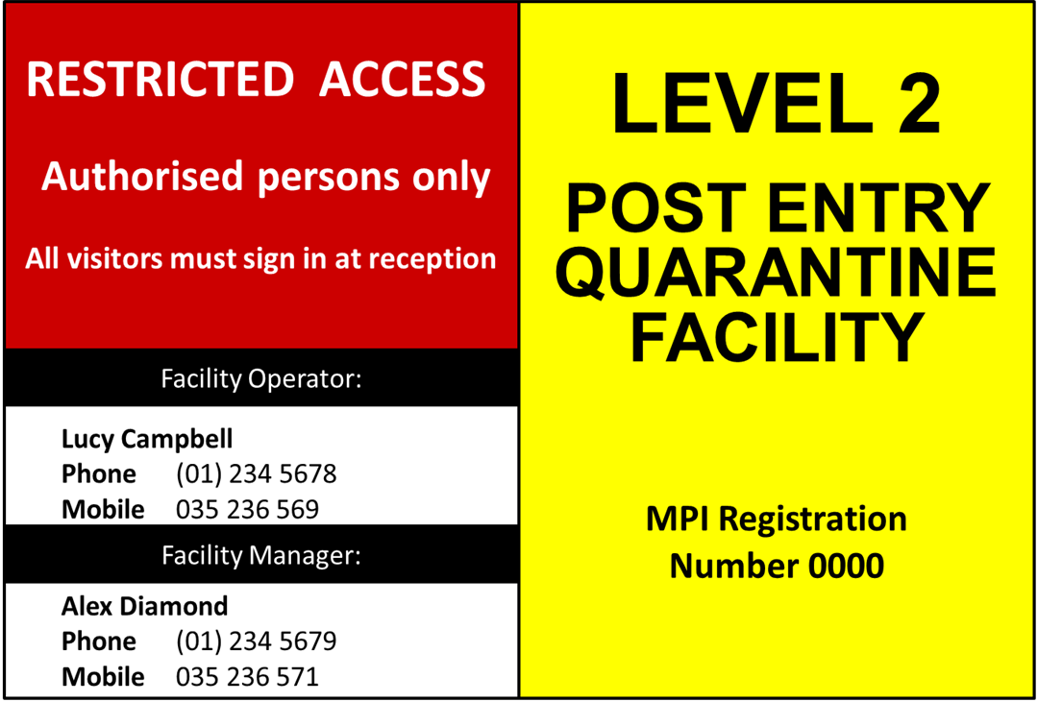

Register of visitors
Name | Organisation | Contact details (phone or email) | Date of visit | Purpose of visit
Mike Andrews | Mr Fixit | mike@mrfixit.com.nz | 15 March 2016 | Replace mesh in unit 2

Footbath refilling records

Date refilled or cleaned | Date refilled or cleaned | Date refilled or cleaned

Example letter of authorisation for collection of plant material from the on-arrival inspection facility

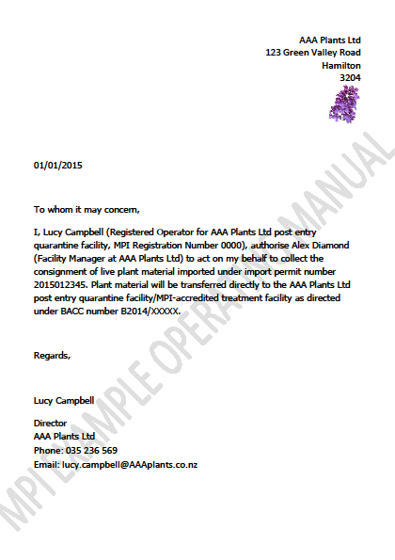

Weekly plant inspection record

Unique consignment number: |  | PEQ start date:

DATE | OBSERVATIONS/COMMENTS | NAME | SIGNATURE

Treatment register

Unique consignment identification number(s), BACC number authorising treatment (where applicable). | Product name & active ingredient | Application rate, quantity used & expiry date | Target pest or disease | Date of application | Quarantine unit | Equipment used & calibration records | Signature of spray applicator

